Cu(II)Sulfate Synthesis From MgSO₄ For Home Chemistry Laboratories
Victor M Rodriguez
The global pandemic has forced many educators to instruct their students online and use home resources to continue their education. Developing chemistry protocols for students and educators that can be performed at home will further help alleviate the pandemic’s pressures on the educational process. This paper explores the process of producing CuSO₄ using products and equipment available in stores or online retailers. The protocol developed in this project produced CuSO₄ pentahydrate for use in a home laboratory, and the process provides several avenues for lessons and classroom discussion.

1. Introduction
Home chemistry laboratories have existed since the origins of chemistry as a scientific discipline. For example, while working on his principal work on gravitation and laws of motion, Sir Isac Newton also explored alchemy. Newton conducted his work based on Victorian occultism; however, the proto-chemistry of his time allowed for further understanding of the world through chemistry. With the Covid 19 pandemic, home laboratories have become more than just the realm of hobbyists. Home laboratories have become essential for many educators and students to continue their education and research with lockdowns and restrictions. Being able to develop and provide low-cost protocols for educators, students and hobbyists will further assist with the progress of knowledge. Procedures developed with this thesis in mind to produce Copper(II)Sulfate from products readily available either at a local pharmacy or through products available online.

2 Methods

2.1 Background
The process for the synthesis of copper (II) sulfate utilized in this protocol is a two-step process. The initial step uses membrane electrolysis to produce sulfuric acid. During membrane electrolysis, the MgSO₄ disassociates into the H₂O solution into the Mg⁺ and SO₄⁻ ions. The solution is then subjected to an electrical current with a membrane of some material placed between the anode and cathode. This process allows the Mg⁺ ion to migrate towards the cathode due to the positive charge of Mg⁺ being attracted to the negative cathode. On the Anode side of the membrane, the SO₄⁻ ions migrate towards the positive anode. The membrane allows for the transfer of the ions to their respective electrodes while preventing the products of the subsequent reactions from traversing the membrane. The chemical reaction that takes place during the process is expressed in Equations 1-3. ¹
(1) MgSO₄ Dissasocation Reaction²
$2MgSO_{4} + H_{2}O→ 2Mg^{+}\left(aq\right) + 2SO_{4}^{−}\left(aq\right)$
(2)Cathode Reaction ³
$4H_{2}O\left(l\right) +4e^{−} +2Mg^{+}\left(Aq\right) → 2Mg{\left(OH\right)}_{2}\left(aq\right) + 2H_{2}^{}\left(g\right)$
(3)Anode Reaction ³
$2H_{2}O\left(l\right)+2SO_{4}^{−}\left(Aq\right) → 2H_{2}SO_{4}\left(aq\right) + O_{2}^{}\left(g\right) +4e^{−}$
The second and final step of this reaction is to combine the H₂SO₄ with copper and H₂O₂ to create Cu(II)SO₄ and H₂O as a final product as shown in equation 4.
(4) $Cu + H_{2}SO_{4} + H_{2}O_{2} → CuSO_{4} + 2H_{2}O$⁴
In order to store the CuSO₄ for future laboratory use, it should be converted to CuSO₄.5H₂O or copper (II) sulfate pentahydrate, through dehydration.
Due to the constraints of finances and resources, rather than purchasing a membrane electrolysis system, one was constructed using three 20 micron pore size filter papers secured in a PVC pipe end.

2.2 Membrane Electrolysis Apparatus Construction
The membrane electrolysis apparatus was constructed using an 11cm long 3.4cm outer diameter schedule 40 PVC pipe, 3.4cm inner diameter PVC coupling, 1mm diameter galvanized steel wire, a 200ml beaker, two 10cm 0.5cm diameter graphite electrodes, two Frey Scientific-584283 platinum electrodes, three 20 micron pore size filter papers, and heat shrink electrical wrap tubes.
The PVC coupling was cut on both connector ends with a PVC pipe cutter, to create two 0.5cm long rings. Place one of the coupling rings 3.8cm from one of the ends (to be referred to as the top end) of the 11cm PVC pipe. On the other end (to be referred to as the bottom end) of the PVC pipe, three filter papers were placed covering the end. The second coupling ring was forced over the filter paper so that it secured the filter papers in place. A 20cm piece of galvanized steel wire was placed around the coupling closest to the top end so that it was further from the top-end than the ring and wrapped around the PVC pipe to make 3 legs 120 degrees apart. (See fig. 1) These legs were bent over the rim of the 200ml beaker. (See fig. 2)
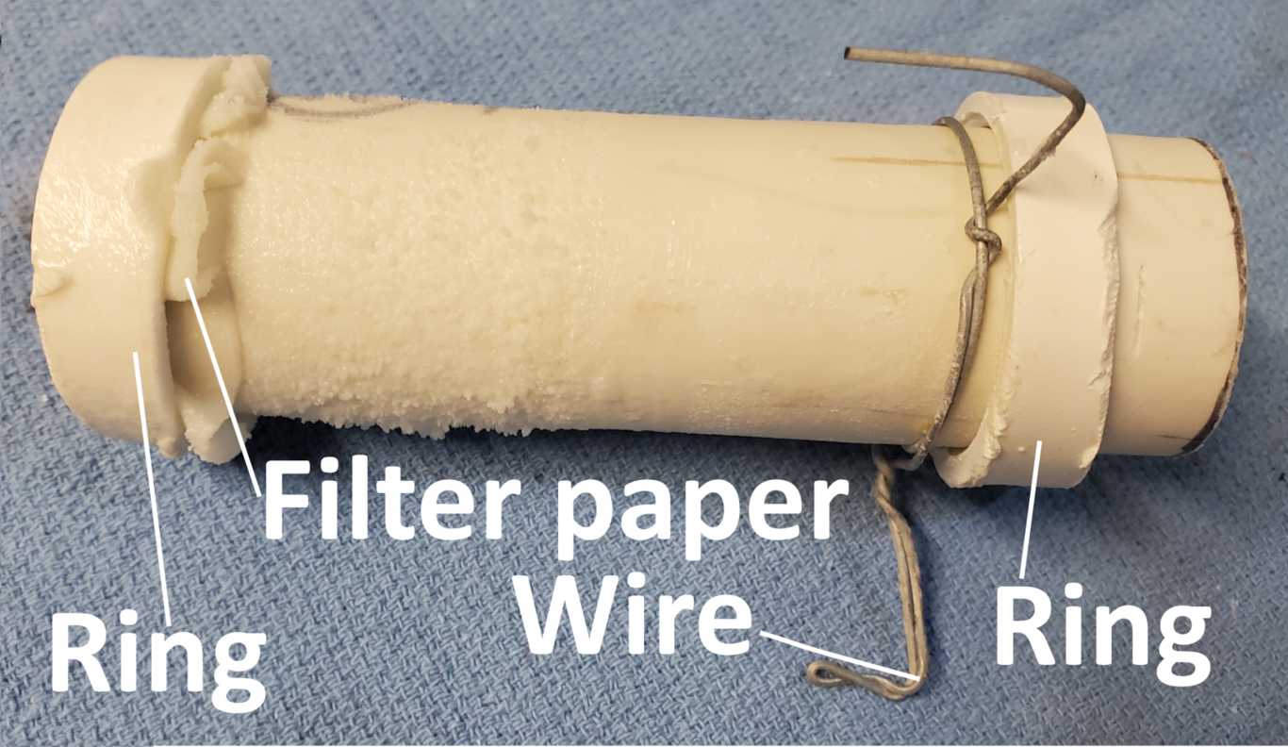
Anode assembley
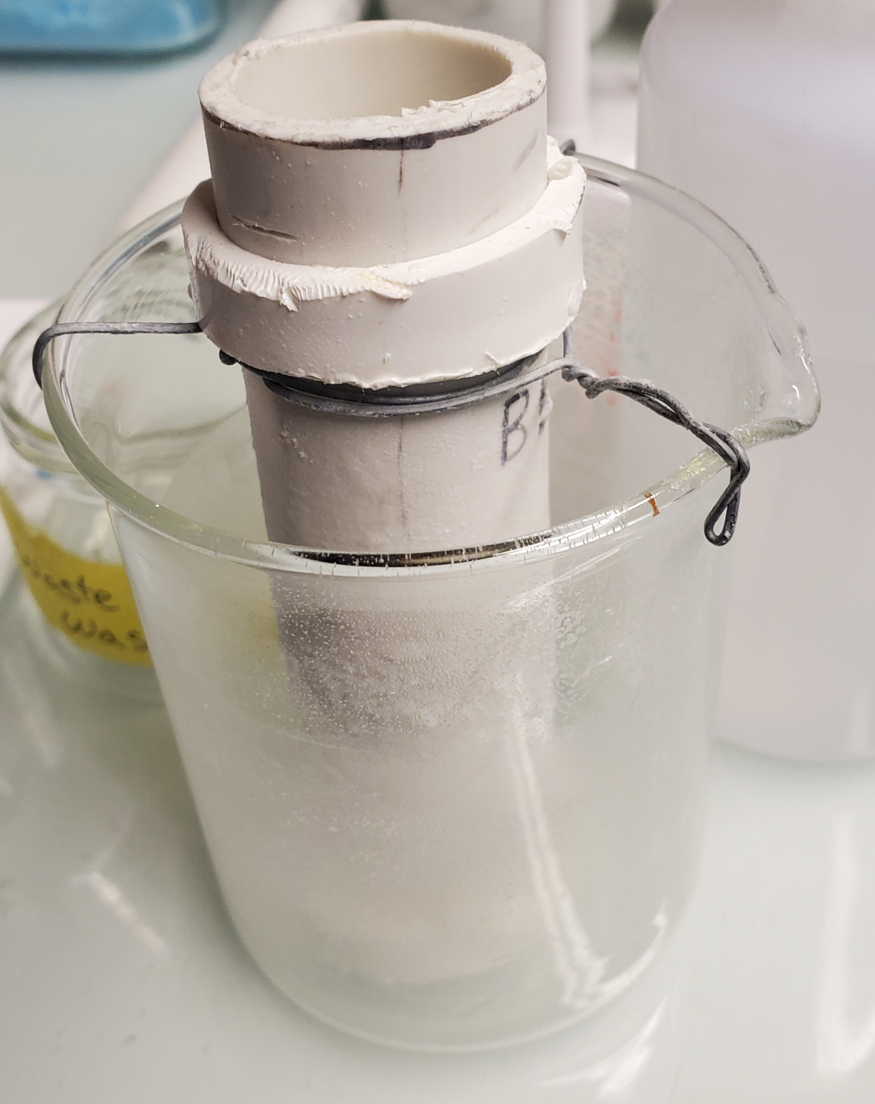
Anode assembly in beaker
On each piece of graphite electrode, a piece of galvanized steel wire was twisted around 3cm from one end, then after 1cm, bent down towards the longer end of the electrode. (See fig. 3) Two electrodes were prepared in this manner to serve as cathodes.

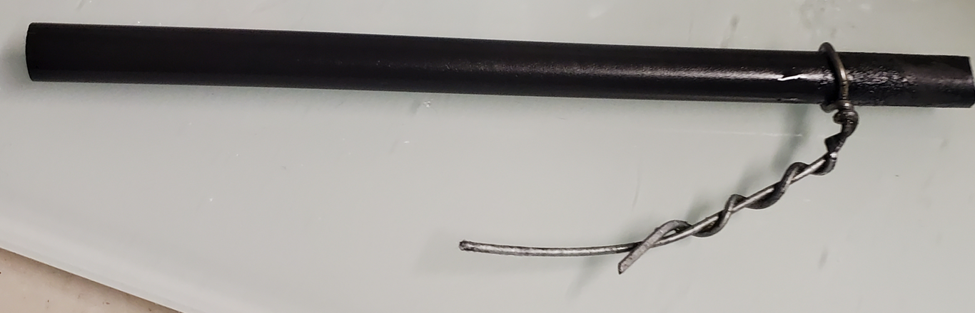
Cathode Assembly
The two Frey Scientific-584283 platinum electrodes were constructed with a 2mm by 2mm platinum foil welded to a led wire. The led wire was encapsulated in a 10cm glass tube with the platinum foil protruding out of one end. The other end had a 10cm copper wire exposed. The two electrodes were placed side by side and the heat shrink wrap was placed around both electrodes. The wrap was placed to cover 3m of the glass and 6cm of copper wire. The heat from a heat gun was applied to the shrink wrap, joining together the two electrodes. (See fig. 4) This wrap was placed in order to protect the copper wire from splashing that occurred as a result of the bubbles escaping the solution. This electrode served as the anode.

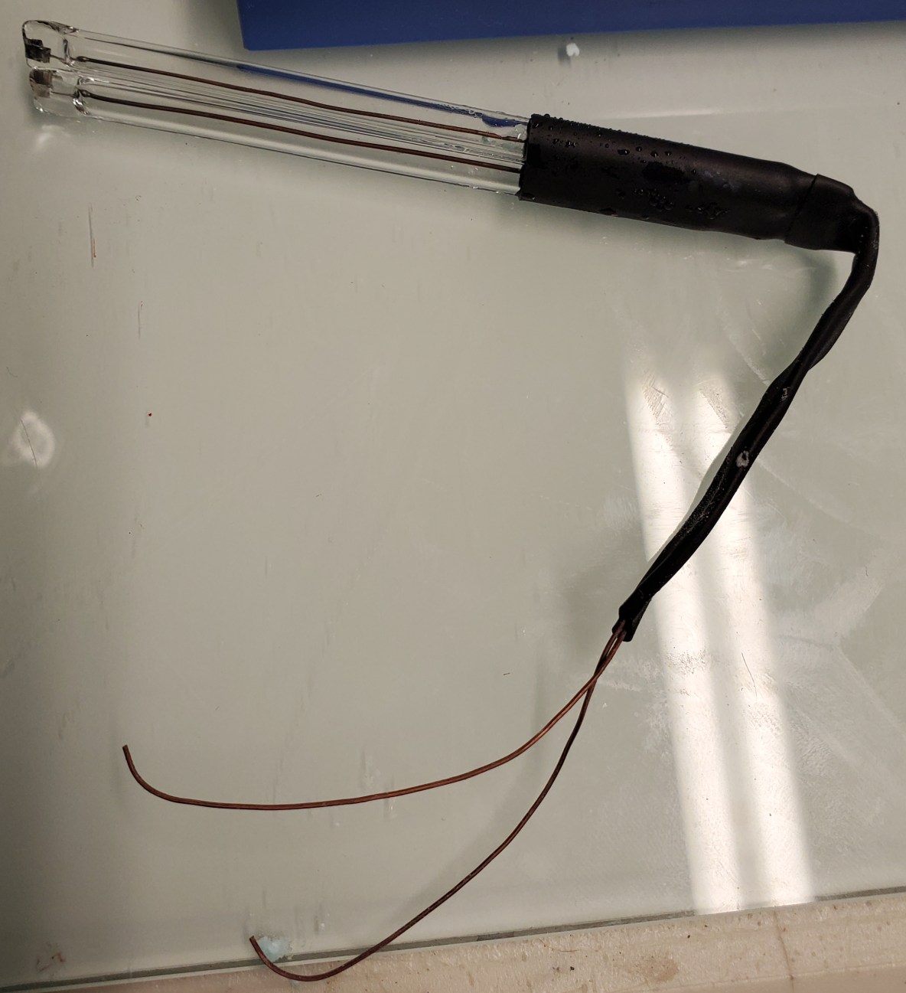
Anode electrode assembly
One cathode was placed to hang over the rim of the 200ml beaker and the anode was hung inside the PVC pipe. (See fig. 5)

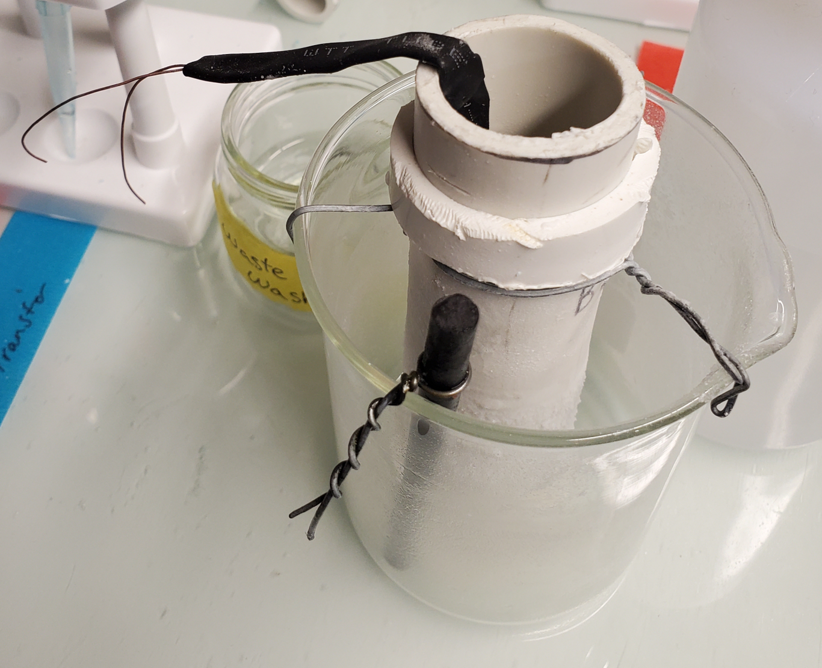
Membrane electrolysis apparatus with electrodes in place

2.3 Sulfuric Acid and Copper (II) Sulfate Synthesis
One of the two graphite electrodes was placed in an 80ml empty flask while the other was hung as shown in figure 5. 400ml of 2.2M concentration MgSO₄ solution was prepared in a glass medium bottle to be used as the primary reactant. A test tube rack was set up with two test tubes and four plastic syringes. One test-tube was labeled and filled with HCl while the other was filled with distilled H₂O and labeled “Anode Rest.” The Syringes were labeled, “H₂O₂“, ”MgSO₄“, ” Mg(OH)₂,” and “H₂SO₄”.
The 200ml beaker was filled with the 2.2M MgSO₄ solution until the 200ml point. Twenty-five extra ml of 2.2M MgSO₄ solution were added above the 200ml mark. The PVC pipe was left empty, and 24 volts of electricity was applied to the electrodes. Over time, the fluid would transfer to the inside of the PVC pipe. After an hour, the fluid concentration inside the PVC pipe was tested using NaHCO₂ and phenolphthalein titration. 1ml of sample fluid was removed and tested. This testing continued for two experiment runs. (See table 1) After each hour test, 20ml of the solution was transferred using the “H2SO₄” syringe to a 250ml flask containing 50g of stripped scrap copper wire. This flask was labeled “CuSO₄ Synthesis“. Then, using the ”MgSO₄” syringe, 20ml of the 2.2M concentration MgSO₄ solution was added to the outside of the PVC pipe.

Hourly Test of H₂SO₄ Concentration
Run | Test | Concentration | Concentration%
1 | 1 | 6.3M | 33.7%
1 | 2 | 6.0M | 32.1%
1 | 3 | 6.8M | 36.4%
2 | 1 | 6.4M | 34.3%
2 | 2 | 6.4M | 34.3%
2 | 3 | 8.1M | 43.4%
2 | 4 | 5.6M | 30.0%
During the process, Mg(OH)₂ crystals form on the cathode, causing the current flow to be impeded over time. After each hour of testing and sample removal, the other cathode electrode was added to the beaker, and the negative electricity clip moved to the new electrode. The original electrode was transferred to the test tube labeled “HCl,” where it was allowed to sit until all the Mg(OH)₂ crystals were decomposed by the HCl. Then the electrode was rinsed off thoroughly to prevent contamination and set aside until the next hour test and solution retrieval.
31ml of 12% H₂O₂ solution was added to the CuSO4 Synthesis flask for every 20 ml of H2SO₄ solution added. The volume needed was derived using the stoichiometric requirements using an average of 6.5M H₂SO₄ solution from table 4, then adding 10% to account for H₂O₂ decomposition. For the first two runs, the amount of H₂O₂ was calculated using equation 5, with the H₂O₂ Molar mass and density being 34.0147g/mol and 1.45g/ml, respectively. The variable cB represents the measured molar concentration of the sample solution in mol/liter.
(5) $c_{B}×1.10×{0.02}_{L}×H_{2}O_{2\left(molar mass\right)}÷H_{2}O_{2\left(density\right)}÷0.12=H_{2}O_{2 mL}$
Equation 5 was simplified to equation six since only cB (representing the tested solution concentration) is variable.
(6) $c_{B}×4.3=H_{2}O_{2\left(volume\right)}$
When the CuSO₄ synthesis flask was full, it was allowed to stand overnight to ensure thorough H₂O₂ decomposition. It was then emptied through a filter to ensure small particles of copper wire did not contaminate the CuSO₄ solution. The CuSO₄ solution was then transferred to an evaporation dish on a hot plate for drying. The solution was dried into a light blue powder and stored in a glass bottle.

2.4 MgSO4 Recycling
Each run was ended when the fluid on the outside of the PVC pipe became too milky and contaminated with Mg(OH)₂. The lab power supply current draw which would reach 0.80A during the beginning of the run would start to struggle to reach 0.65A. After each run, the PVC pipe was removed and the filter paper flushed with distilled H₂O. The remaining contents in the beaker were stirred with a glass stirrer. The sides of the beaker were scraped as well. The milky contents were then vacuum filtered through a 10-micron filter paper. The result was a clear liquid that could be used for future runs.

3 Results and Discussion
Developing this protocol required testing different electrode materials and membrane thicknesses, along with different diameter PVC pipes. A test run was conducted with a graphite electrode as an anode. The graphite anode was able to produce the sulfuric acid; however, the production of O2 deteriorated the graphite and introduced particles into the solution. In some cases, the particles were sufficiently small that the filtration with the laboratory equipment was not sufficient to remove all contamination. The drawback to using the platinum electrodes was the lack of surface area for electrolysis. The platinum foils were 2mm by 2mm each, with 2 of them. Concentrations of up to 67% were achieved with the larger surface area of the graphite electrode.
Originally a 42mm outer diameter PVC pipe was used; however, concentrations struggled to exceed 20%. It is not clear why this was the case. Perhaps the larger diameter allowed for some decomposition to occur across the membrane, or the larger volume slowed the synthesis rate. In addition, it was observed that the conductivity of the solution increased with concentration and that concentration increased faster with conductivity.
Initial test runs applied 12 volts of electricity, and it was observed that the concentration levels would not achieve rates higher than 17%. However, it is essential to note that all concentrations were taken with one hour of electrolysis. Therefore, the prospects of higher concentrations with a more extended electrolysis period between testing and collection were not explored.
All materials and products were obtained either online or at a pharmacy. Although some equipment is more readily available in a lab, this project aimed to produce a protocol that could be performed with products and equipment available online or at retail stores. For example, beakers and flasks could be replaced with glass jars.

Author Information

Corresponding Author
Victor M. Rodriguez
Email: igexoresearch@gmail.com

References
(1) Paidar, M.; Fateev, V.; Bouzek, K. Membrane ElectrolysisHistory Current Status and Perspective. Electrochimica Acta 2016, 209, 737–756. https://doi.org/10.1016/j.electacta.2016.05.209.
(2) Magnesium Sulfate - Physical And Chemical Properties Of Magnesium Sulfate.
(3) Mickey Sarquis, S. H., Lynn Hogue. Chemistry with Charisma; Terrific Science Press, 2009; p 160.
(4) Mlasi, B.; Glasser, D.; Hildebrandt, D. Kinetics of the Decomposition of Hydrogen Peroxide in Acidic Copper Sulfate Solutions. Industrial & Engineering Chemistry Research 2015, 54 (21), 5589–5597. https://doi.org/10.1021/acs.iecr.5b00642.
(5) Martinón-Torres, M. Some Recent Developments in the Historiography of Alchemy. Ambix 2011, 58 (3), 215–237. https://doi.org/10.1179/174582311x13129418299063.
(6) Hoole, D.; Sithambaresan, M. Analytical Chemistry Labs with Kits and CD-Based Instructions as Teaching Aids for Distance Learning. Journal of Chemical Education 2003, 80 (11), 1308. https://doi.org/10.1021/ed080p1308.

